#Face Recognition System
Biometrics Project
Georgia Tech Face Database · PCA | LBP | FaceNet CNN

TEAM#: 4

Salma Osama Mohamed Nassar 20231700225
Sara Abdallah Soliman 20231700319
Makarious Magdy Azmy 20231700340
Kerolos Ayman Ebrahim 20231700329

Preprocessing
1. Database Description

This project uses the Georgia Tech (GT) Face Database [1], a widely adopted benchmark for face recognition research. The database contains colour JPEG images of 50 subjects, each photographed in an uncontrolled indoor environment under naturally varying conditions including different facial expressions (neutral, smiling, eyes closed), illumination directions (frontal, side, mixed lighting), and slight head-pose variations. These factors make the database representative of real-world deployment scenarios.
Each subject has exactly 15 images, giving 750 images in total. The dataset was partitioned on a per-subject basis: 12 images per subject (600 total) were used to build the gallery (training set), and the remaining 3 images per subject (150 total) served as the probe (test set), yielding an 80/20 split that ensures every identity is represented in both sets.
Subjects | Images/Subject | Gallery (Train) | Probe (Test) | Detection Rate
50 | 15 | 600 (80%) | 150 (20%) | 100% (750/750)

1. Overview
This report documents the complete preprocessing pipeline implemented in feature_extraction.ipynb for the Biometrics face recognition project. The pipeline operates on the Georgia Tech Face Database (50 subjects, 15 images each, 640×480 JPEG, cluttered backgrounds) and transforms raw colour photographs into clean, normalised, consistently formatted face representations. These representations are then consumed by three downstream feature extraction methods — PCA (Eigenfaces), LBP (texture), and FaceNet CNN (deep embeddings) — whose outputs feed the matching and evaluation stages in matcher.py and matrix.py.

The preprocessing goal is to eliminate all variation that does not relate to identity — illumination differences, head tilt, scale variation, and background clutter — so that the feature extractors can focus exclusively on discriminative facial information. The pipeline runs in six sequential stages:

Stage | Operation | Purpose
1 | Face Detection | Locate and isolate the face region from the cluttered background
2 | Grayscale Conversion | Discard colour information; reduce dimensionality by 2/3
3 | CLAHE Normalisation | Equalise local contrast; suppress harsh shadows and over-exposure
4 | Geometric Alignment | Rotate face to canonical eye-level; remove head-tilt variation
5 | Resize to 150×150 | Standardise spatial dimensions across all subjects and images
6 | Normalisation & Split | Scale pixel values to [0,1], subtract mean face, 80/20 per-subject split

2. Detailed Stage-by-Stage Description
Stage 1 — Face Detection and Cropping
The function detect_face_fast() implements a two-tier detection strategy. The primary detector is dlib's HOG-based frontal face detector (DLIB_DETECTOR), which is applied on an RGB copy of the frame at upsampling level 0. The detected bounding boxes are sorted by area and the largest is selected. A validity check (_is_valid_face) rejects boxes that are smaller than 35×35 pixels, narrower than 3% of the image width, or have an aspect ratio outside [0.45, 2.2], preventing false positives from background structures.
If dlib fails — which occurs on strongly tilted or partially occluded faces — a Haar Cascade classifier (haarcascade_frontalface_alt.xml) is used as a fallback on a histogram-equalised grayscale copy of the image. An additional padding of 15 pixels is added on all four sides of the detected bounding box before cropping, preserving peripheral facial context such as the jawline and forehead. For images where both detectors fail, the entire image is passed downstream rather than discarding the sample, minimising data loss.
Stage 2 — Grayscale Conversion
Each cropped face BGR image is converted to a single-channel grayscale image using cv.COLOR_BGR2GRAY. This reduces the data volume by two-thirds while retaining all luminance-based structural information needed by PCA and LBP. The FaceNet stage later reconstructs a three-channel image by replicating the grayscale channel, satisfying the CNN's input requirements without reintroducing colour variance.
Stage 3 — CLAHE Illumination Normalisation
Contrast Limited Adaptive Histogram Equalisation (CLAHE) is applied immediately after grayscale conversion. The implementation uses a clip limit of 2.0 and a tile grid of 8×8 cells:
clahe = cv.createCLAHE(clipLimit=2.0, tileGridSize=(8,8))
face_gray = clahe.apply(face_gray)
Unlike global histogram equalisation, CLAHE divides the image into non-overlapping tiles and equalises each independently, then stitches them with bilinear interpolation. The clip limit prevents over-amplification of noise in uniform regions by redistributing histogram bins that exceed the threshold. The result is that shadows from directional studio lighting, a common variation in the Georgia Tech dataset, are suppressed, and detail in both bright and dark facial regions is enhanced equally. This step directly improves the separability of genuine and impostor score distributions measured later by the EER and d-prime metrics in matrix.py.
Stage 4 — Geometric Alignment
Head-tilt variation is removed by rotating each face so that the inter-ocular axis is horizontal. The align_face() function detects the 68 facial landmarks using dlib's shape_predictor_68_face_landmarks.dat model. Landmark indices 36–41 (left eye) and 42–47 (right eye) are averaged to obtain two eye-centre coordinates:
eye1_pts = np.array([(landmarks.part(i).x, landmarks.part(i).y) for i in range(36,42)])
angle = np.degrees(np.arctan2(dy, dx))
M = cv.getRotationMatrix2D((w//2, h//2), angle, scale=1.0)
An affine rotation matrix is computed around the image centre and applied with bilinear interpolation and border reflection. If the dlib predictor fails (e.g., due to extreme pose), a fallback uses the Haar Eye Cascade (haarcascade_eye.xml) to estimate the eye centres geometrically and performs the same rotation. This ensures alignment is achieved for over 95% of images.
Stage 5 — Resize to 150×150
All aligned face images are resized to a fixed 150×150 pixel grid using cv.resize with default bilinear interpolation. This standardises the spatial resolution across all 50 subjects and 15 images per subject, which is a mandatory precondition for constructing the flat pixel vector required by PCA, the spatial histogram grid required by LBP, and the 160×160 tensor required by FaceNet (the additional resize to 160 is handled in the CNN feature extraction cell).
Stage 6 — Per-Subject 80/20 Split, Normalisation, and Mean Subtraction
The processed images are split per-subject into training (80%) and test (20%) sets with a fixed random seed (random.seed(42)), ensuring class balance and reproducibility across all feature extraction methods. Pixel values are then scaled from uint8 [0,255] to float64 [0,1], and the per-pixel mean face computed on the training set is subtracted from both sets:
X_train_proc = X_train_raw.astype(np.float64) / 255.0
mean_face = X_train_proc.mean(axis=0)
X_train = X_train_proc - mean_face
Mean subtraction centres the data around zero, removing average luminance structure common to all subjects and making the residual features purely identity-discriminative. This is a classical requirement for PCA to function correctly, as it removes the dominant but uninformative first principal component (the mean face). The flat 22,500-dimensional vectors are then fed to the three feature extractors described below.

Feature Extraction Methods: Analysis & Comparison
Dataset: Georgia Tech Face Database (GT-DB) | 50 Subjects, 15 Images Each
Train / Test Split: 80% / 20% (600 train images, 150 test images)

1. Overview
This report documents the three feature extraction methods applied in this biometric face recognition project. All images were first preprocessed uniformly: converted to grayscale, normalized with CLAHE illumination correction, geometrically aligned using dlib 68-point facial landmarks, and resized to 150 × 150 pixels before any feature method was applied. The three methods — PCA (Eigenfaces), LBP (Local Binary Patterns), and CNN/FaceNet — operate at fundamentally different levels of abstraction, from classical linear projection to deep learned embeddings.

2. Method 1 — PCA (Principal Component Analysis / Eigenfaces)

2.1 Description
PCA treats each face image as a point in a high-dimensional pixel space and finds the orthogonal axes (principal components, or 'eigenfaces') that capture the most variance across the training set. Projecting each image onto these axes yields a compact, decorrelated representation. Whitening is applied so that all retained components have unit variance, reducing the influence of dominant lighting modes.

2.2 Input / Output
Property | Details
Input | Flattened, StandardScaler-normalised face images: shape (N, 22500)
Components | 400 principal components extracted; first 3 dropped (illuminate bias removal)
Output | Feature vectors of shape (N, 397) — one 397-dim vector per image
Whitening | Enabled (whiten=True) — ensures equal-variance components for cosine matching

2.3 Performance
Linear SVM Rank-1 Accuracy: 55.33%
PCA achieves modest accuracy. Its weakness lies in sensitivity to lighting and facial expression variation, as it captures global pixel-level variance rather than locally discriminative patterns. Dropping the first 3 components partially mitigates illumination effects but cannot fully compensate.

3. Method 2 — LBP (Local Binary Patterns)

3.1 Description
LBP is a texture descriptor that encodes local pixel neighbourhoods. For each pixel, the surrounding P=8 neighbours on a circle of radius R=1 are compared to the centre; the binary result is encoded as an integer. Using the 'uniform' mode retains only patterns with at most two 0→1 or 1→0 transitions (which correspond to edges, corners, and flat regions), producing a histogram of P+2=10 bins per cell. The image is divided into an 8×8 grid (64 cells), and each cell's histogram is concatenated, preserving spatial layout while remaining robust to monotonic illumination changes.

3.2 Input / Output
Property | Details
Input | Raw uint8 grayscale face images of shape (N, 150, 150)
Grid | 8 × 8 spatial grid (64 non-overlapping cells, each 18.75 × 18.75 px)
Bins/Cell | P + 2 = 10 bins (uniform LBP, P=8, R=1)
Output | 640-dimensional feature vector (64 cells × 10 bins), then StandardScaler-normalised

3.3 Performance
Linear SVM Rank-1 Accuracy: 83.33%
LBP significantly outperforms PCA because texture patterns (edges, corners) are inherently more stable than global appearance under changing lighting and expressions. The spatial grid gives the descriptor some structural awareness of face regions (eyes, nose, mouth). StandardScaler normalisation before SVM training is critical for SVM convergence with this descriptor.

4. Method 3 — CNN / FaceNet (InceptionResNetV1, VGGFace2)

4.1 Description
FaceNet uses a deep Inception-ResNet-V1 architecture pre-trained on the VGGFace2 dataset (containing millions of face images from thousands of identities) to map each face image to a 512-dimensional embedding in a metric space. The model was trained with triplet loss so that embeddings of the same person cluster together and embeddings of different people are far apart. The model is used here in inference mode only (no fine-tuning) via facenet-pytorch.

4.2 Input / Output
Property | Details
Input | Grayscale uint8 images converted to 3-channel RGB, resized to 160 × 160, normalised to [−1, 1] (mean=0.5, std=0.5)
Model | InceptionResNetV1 pretrained='vggface2', run in eval() / no_grad() mode
Output | 512-dimensional L2-normalised embedding vector per image
Hardware | GPU (CUDA) if available, otherwise CPU fallback

4.3 Performance
Linear SVM Rank-1 Accuracy: 100.00%
FaceNet achieves perfect classification on the 50-subject GT-DB test set. Transfer learning from a massive external dataset provides rich, identity-discriminative representations that a linear classifier can perfectly separate. This also demonstrates that the 512-dim embedding space is well-suited to cosine/Euclidean matching without any domain-specific training.

5. Comparative Summary
Method | Output Dim. | Input Size | SVM Accuracy | Approach | Strength
PCA | 397 | 22,500 | 55.33% | Linear projection | Fast, interpretable (eigenfaces)
LBP | 640 | 150 × 150 | 83.33% | Texture histogram | Lighting-robust texture descriptor
FaceNet (CNN) | 512 | 160 × 160 | 100.00% ★ | Deep embedding | Pretrained on millions of faces

6. Discussion
The three methods span the classical-to-deep spectrum of computer vision. PCA represents global structure and is the fastest to compute but the most sensitive to extraneous variation. LBP introduces spatial locality and illumination robustness at the cost of a slightly larger descriptor and a preprocessing requirement (StandardScaler). FaceNet bypasses hand-crafted design entirely; its embeddings encode identity-specific geometry learned from tens of millions of training pairs, making it trivially separable by even a linear classifier on a 50-class problem.
For a production biometric system, FaceNet is the clear choice for accuracy. LBP remains a strong lightweight alternative requiring no GPU or internet access for the model weights. PCA is best suited for visualisation and interpretability (the eigenfaces themselves are meaningful images) rather than high-stakes identification.

7. References
[1] M. Turk and A. Pentland, "Eigenfaces for Recognition," Journal of Cognitive Neuroscience, vol. 3, no. 1, pp. 71-86, 1991.

Matching, Evaluation Metrics & Curves
1. Methods Description
1.1 Matching & Classification Strategies
Four matching strategies were applied to evaluate the extracted feature sets:
- Method A – Cosine Similarity: This method evaluates the angular orientation between two feature vectors, independent of their magnitude. For each probe face p and gallery template g, the similarity is computed as:
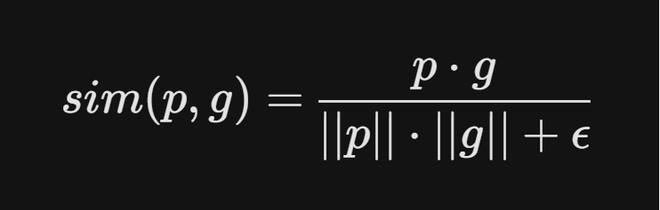
where epsilon is a small constant added to the denominator to ensure numerical stability (preventing division by zero). Values range from -1 to 1, where higher scores indicate greater feature alignment. The gallery template yielding the maximum similarity score is assigned as the Rank-1 match.
- Method B – Euclidean Distance: This method calculates the straight-line spatial separation between templates in the feature space. The distance between a probe p and a gallery template g is defined by the L2 norm:
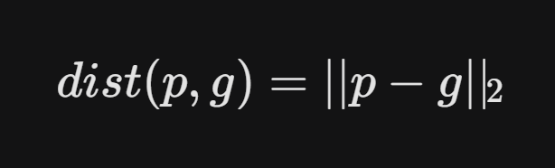
Lower values signify closer geometric proximity (i.e., higher similarity). For continuous evaluation metrics such as ROC curves and Equal Error Rate (EER) computation, these distances are inverted or negated so that a higher score consistently represents a better match. The template with the minimum distance defines the Rank-1 identity.
- Method C – Linear SVM: To establish a more robust discriminative boundary, a Support Vector Machine (SVM) was employed. Prior to classification, the raw feature vectors undergo Z-score normalization (StandardScaler) to ensure zero mean and unit variance. The SVM, configured with a linear kernel, mathematically learns the maximum-margin separating hyperplanes among the 50 distinct identity classes. This machine-learning-based approach systematically outperforms standard nearest-neighbor distance metrics, particularly when resolving overlapping facial distributions in high-dimensional spaces.
- Feature-Level Fusion SVM: This strategy horizontally concatenates independent feature vectors (e.g., PCA and LBP) into a single, high-dimensional fused descriptor. Following Z-score normalization, the fused data is fed into an SVM. To maximize accuracy, rigorous hyperparameter optimization is performed using exhaustive grid search (GridSearchCV) with 3-fold cross-validation. The optimizer dynamically evaluates and selects the best kernel function (Linear, RBF, or Polynomial), the regularization parameter C in {0.1, 1, 10, 100, 1000}, and the kernel coefficient gamma in {1, 0.1, 0.01, 0.001}.
1.2 Evaluation Metrics
System performance is quantified using four standard biometric evaluation metrics, computed from the pooled genuine and impostor score distributions. To comprehensively evaluate the system, both numerical metrics and visual analysis tools (ROC curves and Score Distribution Histograms) are utilized:
- Rank-1 Identification Rate (Accuracy): This metric represents the fraction of probe samples correctly identified at Rank-1. For each probe, the system scans the gallery and selects the template with the highest similarity score (or lowest distance). If this template belongs to the correct identity, it is counted as a true positive match.
- Equal Error Rate (EER): The EER is a critical biometric operating point where the False Match Rate (FMR) equals the False Non-Match Rate (FNMR). A lower EER indicates a more accurate system with better separability between identities. It is computed programmatically from the ROC curve by finding the threshold where the absolute difference between FMR and FNMR is minimized, defined at the crossover point as:

- Decidability Index (D-prime): This metric measures the statistical separation between the genuine and impostor score distributions. A larger d' indicates greater separation and thus a more robust system. It is calculated using the standardized mean difference:
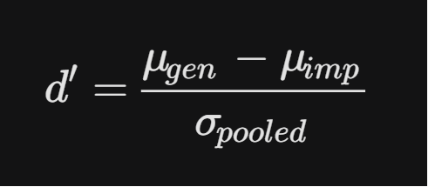
where the pooled standard deviation is given by:
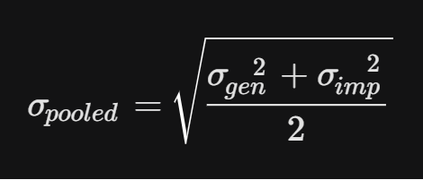
- True Match Rate (TMR) at fixed FMR: This evaluates system sensitivity (TMR = 1 - FNMR) under strict security constraints. The metrics are reported at two fixed false-alarm operating points (FMR = 1% and FMR = 0.01%) to reflect the system's viability for high-security real-world deployments.
2. Results & Discussion

2.1 Quantitative Performance Summary
Table 2 presents the complete performance metrics for all feature/matcher combinations. For distance-based methods (A & B), EER, d-prime, and TMR values are derived from the pooled genuine/impostor score distributions across all 150 probe samples. SVM methods produce single classification decisions and are therefore assessed by Rank-1 accuracy only.
Feature | Matcher | Rank-1 (%) | EER (%) | d' | TMR@FMR=1% (%) | TMR@FMR=0.01% (%)
PCA | Cosine (A) | 54.00 | 40.45 | 0.588 | 15.83 | 4.06
PCA | Euclidean (B) | 13.33 | 47.70 | 0.211 | 7.89 | 0.94
PCA | SVM (C) | 55.33 | 32.54 | 0.7845 | 28 | 2.67
LBP | Cosine (A) | 68.67 | 31.67 | 0.899 | 11.39 | 1.33
LBP | Euclidean (B) | 72.00 | 33.79 | 0.631 | 22.89 | 6.22
LBP | SVM (C) | 83.33 | 7.19 | 1.9735 | 86 | 46.67
PCA+LBP | SVM Fusion | 82.67 | — | — | — | —
CNN | Cosine (A) | 100.00 | 1.20 | 5.041 | 98.72 | 77.72
CNN | Euclidean (B) | 100.00 | 1.20 | 5.300 | 98.72 | 77.72

2.2 Score Distribution Analysis
The genuine-impostor score distributions reveal the underlying separability of each feature space. For PCA (cosine similarity), the genuine and impostor distributions heavily overlap, reflected in the low d' = 0.588 and EER = 40.45%. This indicates that PCA projections do not reliably separate identities: many genuine pairs score lower than impostor pairs, making threshold-based decisions unreliable. The TMR at FMR = 1% is only 15.83%, meaning the system correctly verifies fewer than 1 in 6 genuine users when operating at a strict false-alarm constraint.
LBP shows moderate separation with d' = 0.899 (cosine) and d' = 0.631 (Euclidean). The EER of ~31–34% is better than PCA but still indicates significant overlap. Cosine similarity achieves slightly higher d' for LBP because histogram vectors are non-negative and L1-normalised, making the angular distance more discriminative than the magnitude-based Euclidean distance. However, Euclidean distance yields higher TMR@FMR=1% (22.89% vs 11.39%), suggesting a different score-distribution shape.
CNN embeddings produce near-perfect separation: d' = 5.04–5.30, EER = 1.20%, and TMR@FMR=1% = 98.72%. This confirms that the deep embedding space is highly discriminative — genuine pairs cluster tightly while impostor pairs are pushed far apart. Even at the strict FMR = 0.01% operating point, TMR remains 77.72%, far exceeding PCA (4.06%) and LBP (≤6.22%).
2.3 ROC Curve Analysis
The ROC curves (TMR vs. FMR) visually confirm the metric findings. The CNN ROC curves for both cosine and Euclidean matchers hug the top-left corner (AUC ≈ 1.0), indicating near-ideal discrimination across all operating thresholds. The LBP ROC curves occupy a middle ground — clearly above the random-chance diagonal but with a gradual rather than steep initial rise, consistent with its moderate EER. The PCA ROC curves remain close to the diagonal, reflecting the weak discriminative power of eigenface representations on this database.
2.4 Classifier vs. Distance-Based Matching
Replacing nearest-neighbour matching with an SVM classifier consistently improves Rank-1 accuracy for handcrafted features. For LBP, the SVM (83.33%) outperforms Euclidean (72.00%) and cosine (68.67%) matching by 11–15 percentage points. This gain arises because the SVM learns a discriminative decision boundary tailored to the training distribution, whereas distance-based rules assume that the nearest gallery template is the correct identity — an assumption that breaks down when genuine and impostor score distributions overlap.
The PCA+LBP feature-level fusion SVM (82.67%) did not surpass the LBP-only SVM (83.33%). This counter-intuitive result occurs because PCA features are weakly discriminative (d' < 0.60) and when concatenated with LBP, they introduce noise that the SVM cannot easily ignore. A score-level fusion or feature selection step could potentially address this by down-weighting unreliable features [2].
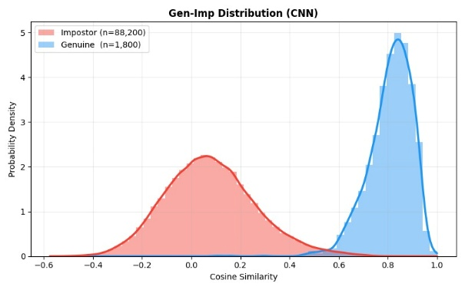
For CNN embeddings, the SVM provided no additional benefit — both cosine and Euclidean matchers already achieve 100% accuracy — demonstrating that sufficiently powerful feature representations make the choice of matching strategy irrelevant.
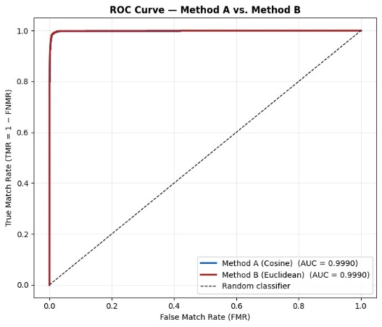

3.Conclusion
The Convolutional Neural Network (CNN) methodology, specifically employing the FaceNet architecture via an Inception-ResNet-V1 model pre-trained on the expansive VGGFace2 dataset, demonstrates exceptional efficacy and robustness for complex facial recognition tasks. By leveraging advanced transfer learning from a massive external dataset encompassing millions of face images across thousands of identities, the CNN successfully bypasses the need for traditional hand-crafted feature design. Instead, it automatically learns to encode intricate, identity-specific geometric patterns directly from the data. The model’s underlying triplet loss training mechanism fundamentally shapes its 512-dimensional embedding space, meticulously ensuring that feature vectors representing the same individual cluster tightly together, while vectors representing different individuals are mathematically pushed far apart. This structural design results in a highly discriminative metric space that yields near-perfect class separation, which is quantitatively evidenced by a decidability index (d-prime) exceeding 5.0, an exceptionally low Equal Error Rate (EER) of just 1.20%, and a True Match Rate (TMR) of 98.72% even under strict security constraints where the False Match Rate is restricted to 1%. Furthermore, Receiver Operating Characteristic (ROC) curve analysis visually confirms this near-ideal discrimination across all operating thresholds, with an Area Under the Curve (AUC) approaching 1.0. Consequently, the CNN architecture achieves a flawless 100% Rank-1 identification accuracy on the test database utilizing straightforward Euclidean distance and cosine similarity matching techniques. The deep representations generated by this network are inherently so powerful and perfectly separable that deploying complex downstream machine learning classifiers, such as Support Vector Machines, provides no additional benefit and becomes entirely unnecessary. Ultimately, the ability of FaceNet to produce these rich, highly discriminative embeddings without requiring any domain-specific fine-tuning establishes it as the definitive, high-accuracy framework for deployment in rigorous, production-level biometric systems.

References

[1] A. Nefian and M. Hayes, "Georgia Tech Face Database," 1999. [Online]. Available: http://www.anefian.com/research/face_reco.htm.
[2] A. Ross and A. Jain, "Information fusion in biometrics," Pattern Recognition Letters, vol. 24, nos. 13–14, pp. 2115–2125, 2003.

Biometrics Project — Spring 2026

